IMPORTANT SAFETY WARNING
BUBBLE BATH MACHINE
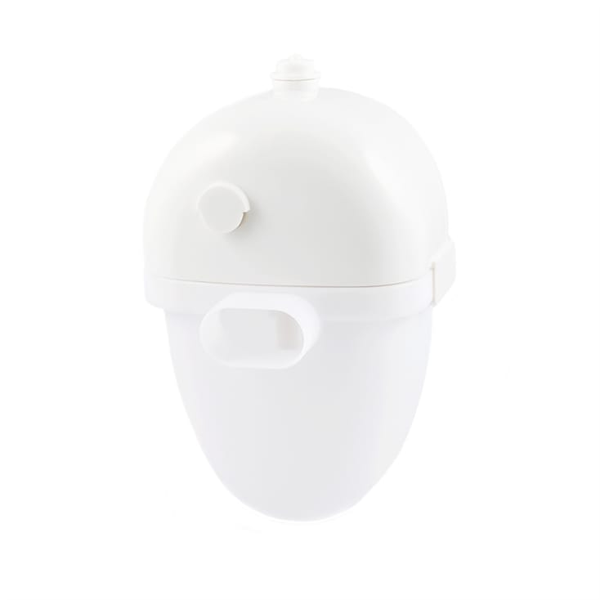
SMALL PARTS WARNING
This product has three suckers used to mount the unit on the bath/bath tiles. In use, two of these suckers may become detached, presenting a possible choking hazard to young children.

ACTION TO BE TAKEN
This product must not be used by children under 36 months old.
Adults and older children can continue to use this product. However, we advise children should always be supervised.
This notice applies to all Bubble Bath machines sold online by Find Me A Gift from 2012 to 2019.

For further information, please call 01926 818 800

